Lab Task
Name: Usman Ali Haseeb
Roll no: 240
Section: BSAI-3D

Task 1: Breadth-First Search (BFS) and Depth-First Search (DFS)
Objective: To manually trace BFS and DFS on a graph, starting from node A and searching for goal G. We record the queue/stack states, processed nodes, visit order, and final path.
2. Breadth-First Search (BFS)
Definition: BFS explores nodes level by level using a queue (FIFO: First In, First Out).

Conclusion:
- BFS uses a Queue (FIFO).
- BFS explores level by level
- Both algorithms find the same shortest path in this graph.
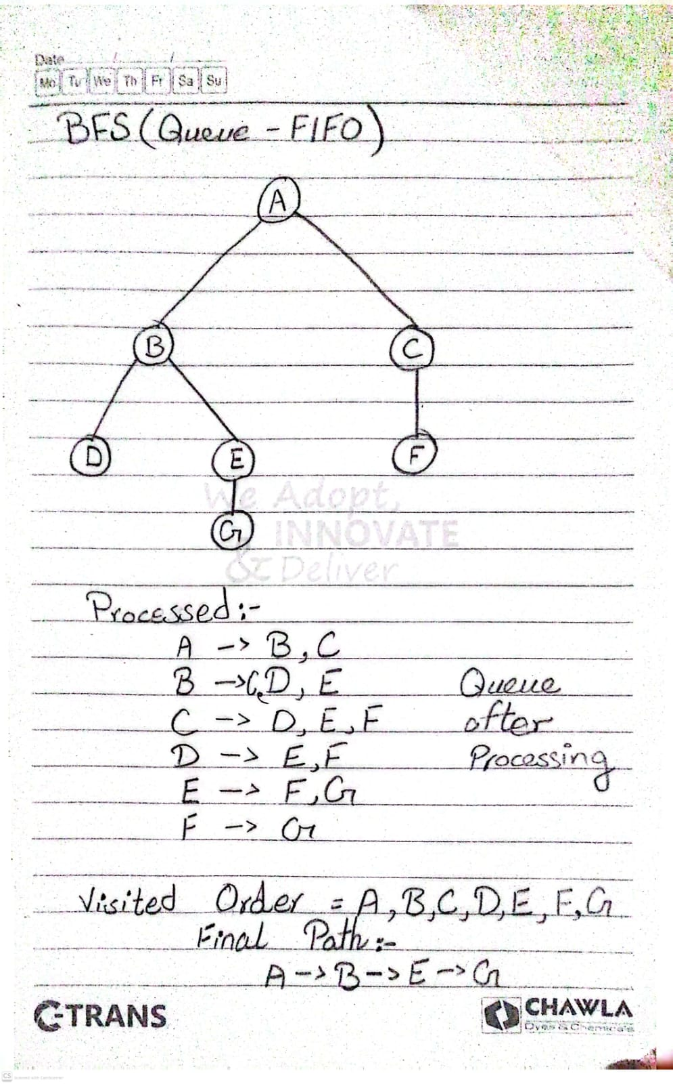
3. Depth-First Search (DFS)
Definition: DFS explores one branch as deeply as possible before backtracking. It uses a stack (LIFO: Last In, First Out), or an equivalent recursive procedure.
]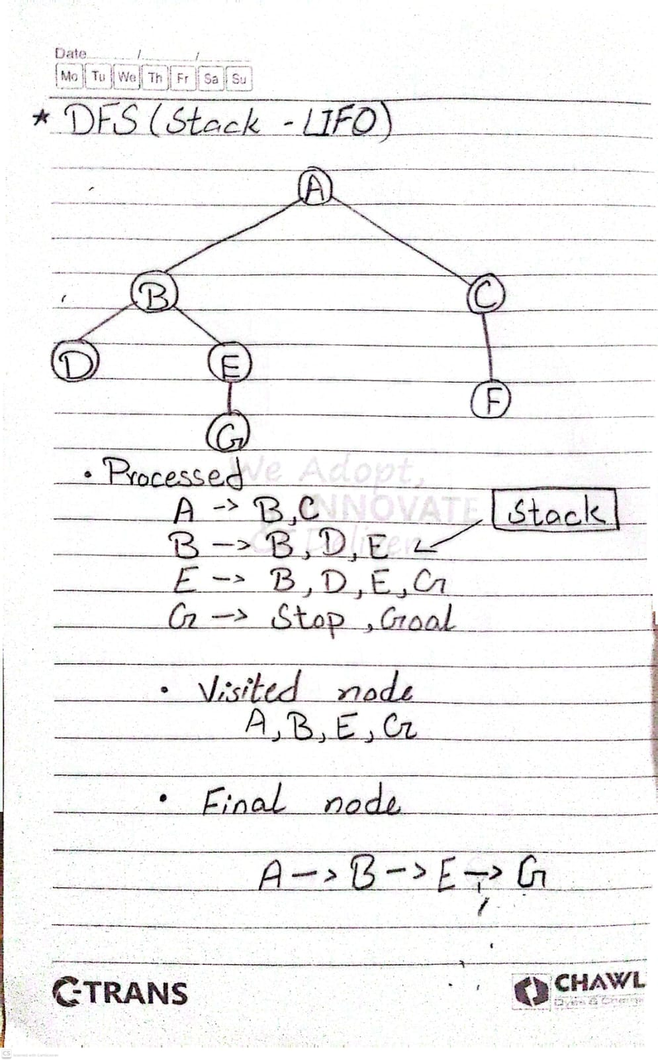
Conclusion
- DFS uses a Stack (LIFO).
- DFS explores deeper nodes first.
- Both algorithms find the same shortest path in this graph.

Task 2: Depth-Limited Search (DLS) and Iterative Deepening DFS (IDDFS)
1. Objective
Implement DLS and IDDFS using the same original A–G graph.
2. Original Graph
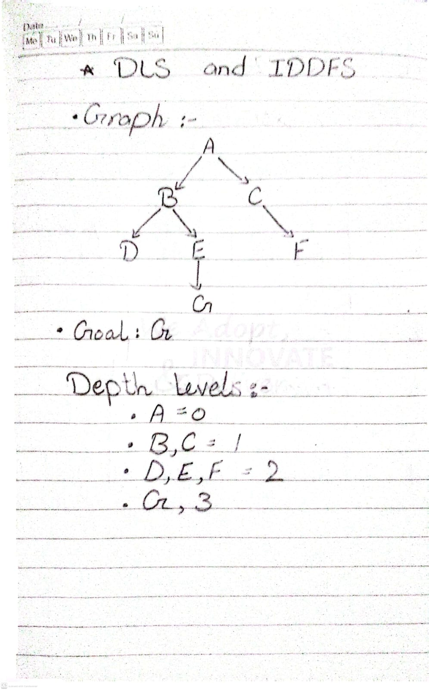
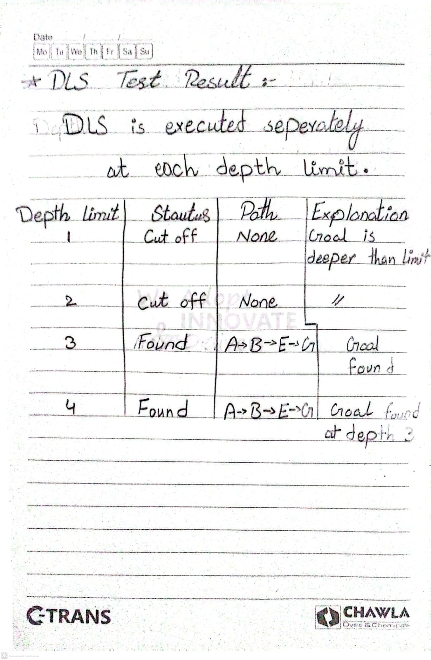
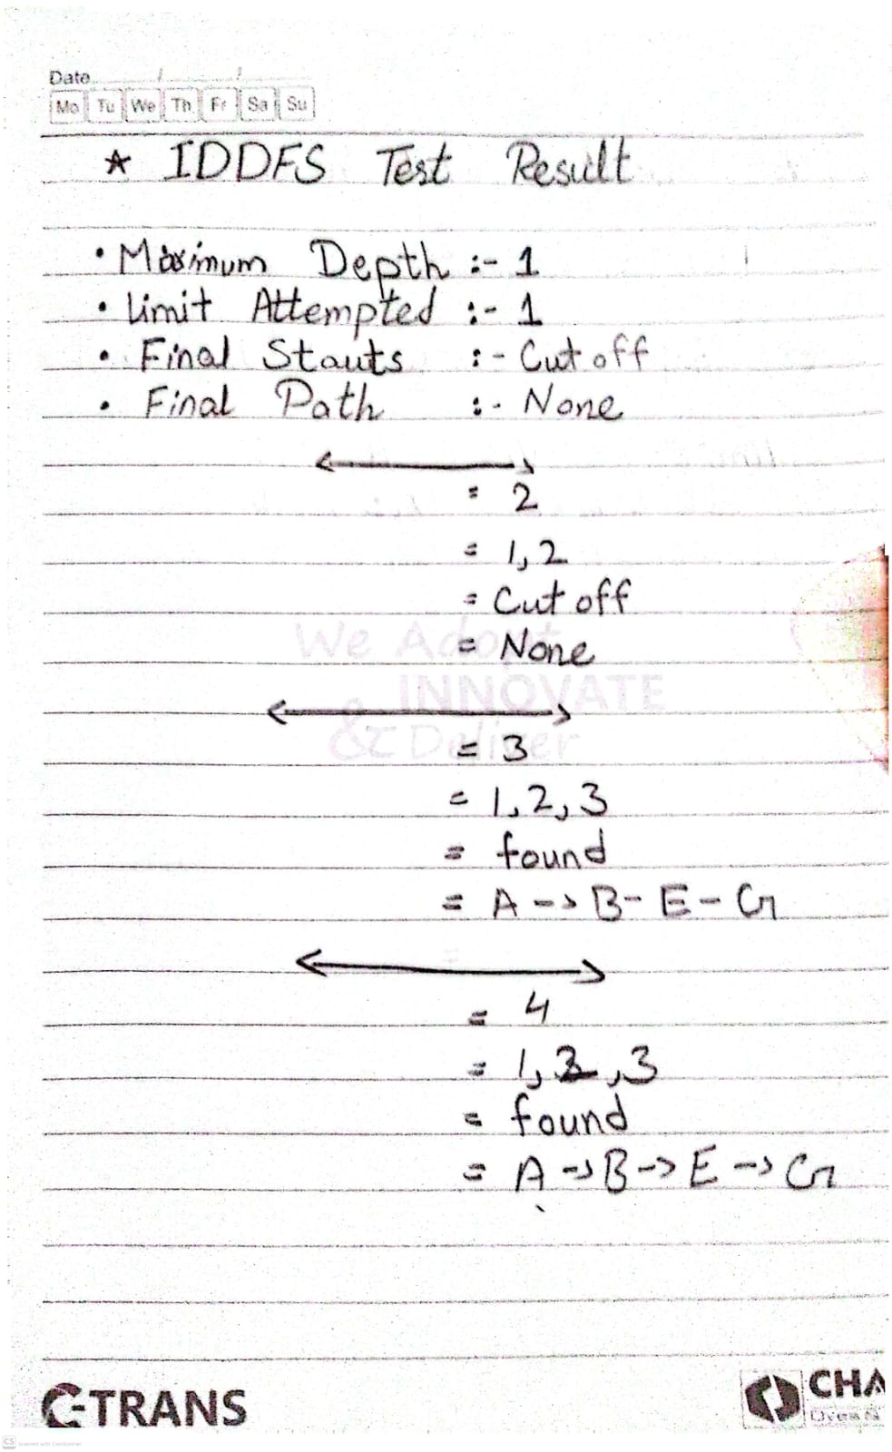
6. Why Limits Below 3 Do Not Succeed
- Limit 1: Only nodes at depth 0 and 1 can be explored. Goal G is at depth 3.
- Limit 2: Search can reach D, E and F, but cannot expand E to reach G.
- Limit 3: Search reaches G through A → B → E → G.
- Limit 4: Goal is still found at depth 3; extra depth is unnecessary.
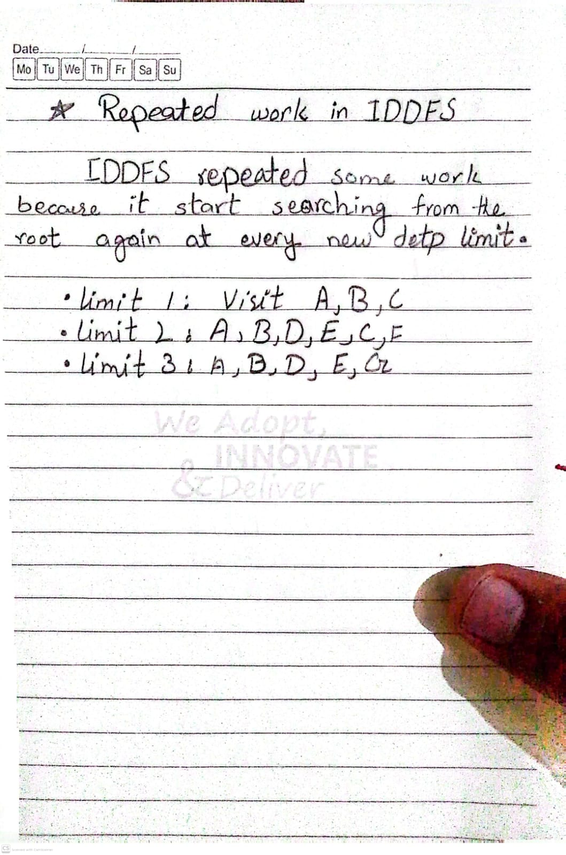
Conclusion
DLS and IDDFS were successfully implemented using the original A–G graph. DLS found the goal at limits 3 and 4. IDDFS found the goal when its maximum depth was 3 or 4, but stopped at depth 3 after success.
Path-local cycle checking prevents revisiting a node already present in the current search path. IDDFS performs repeated work but efficiently finds the goal without searching unnecessarily deep.
Final Goal Path: A → B → E → G
Final Goal Depth: 3
Task 3: Uniform Cost Search (UCS 1. Objective)
Weighted Graph:
I am using the original A–G graph and adding one extra corridor (A → G) as a controlled extension to demonstrate why BFS and UCS can produce different results.

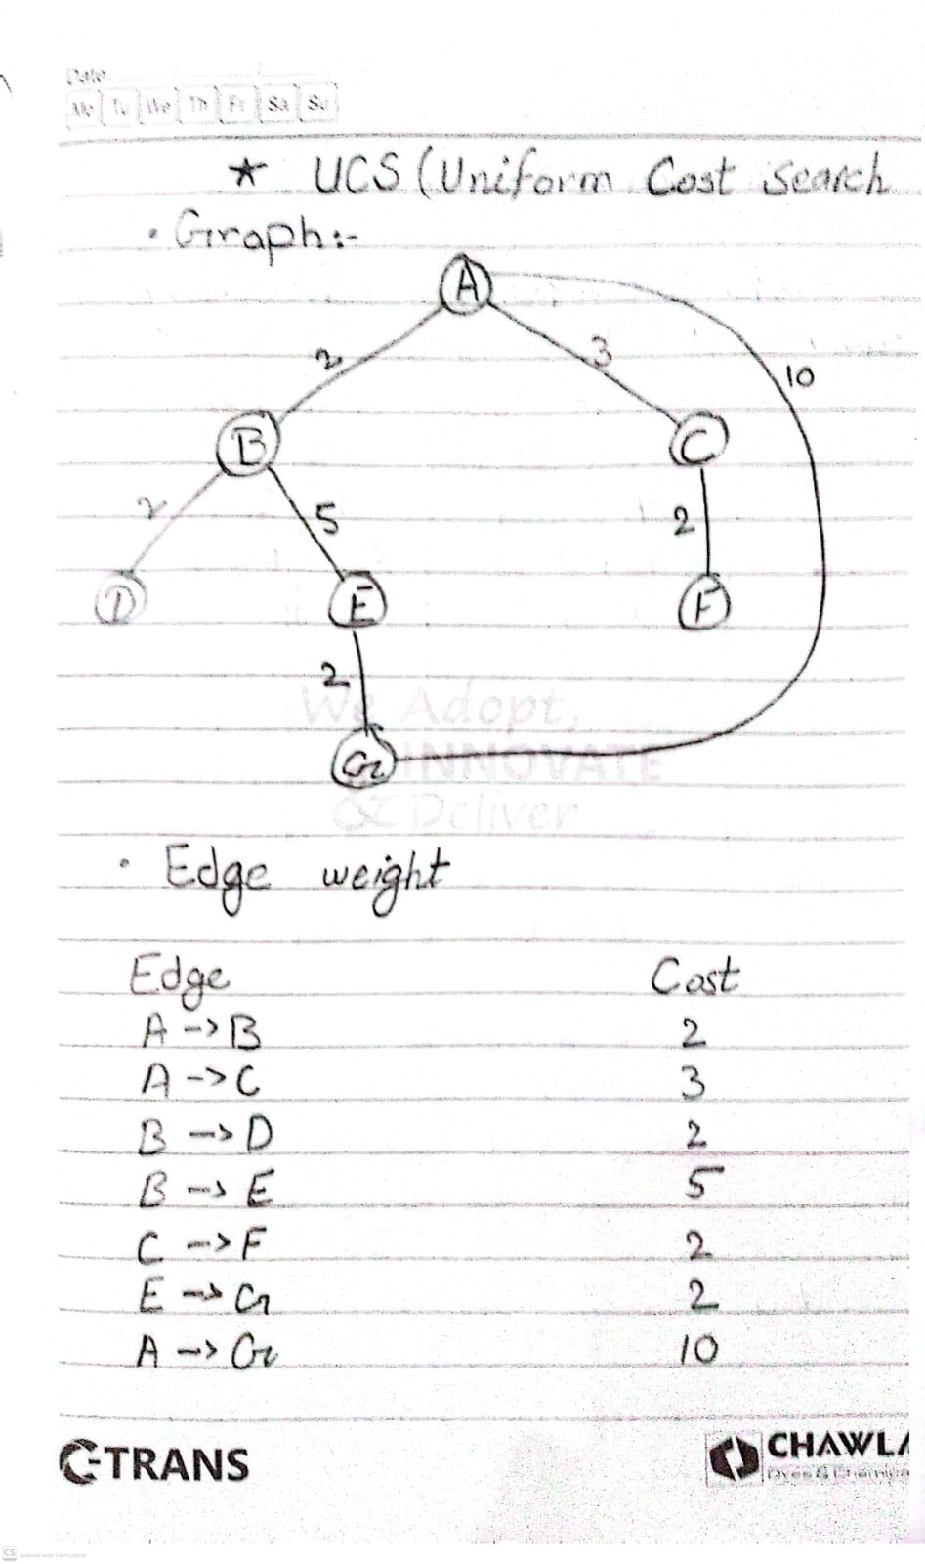
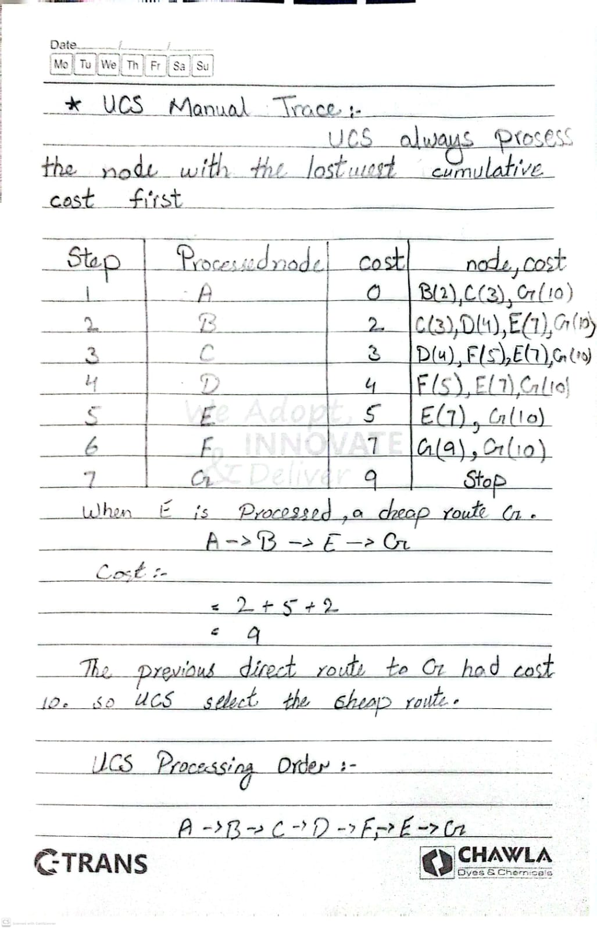
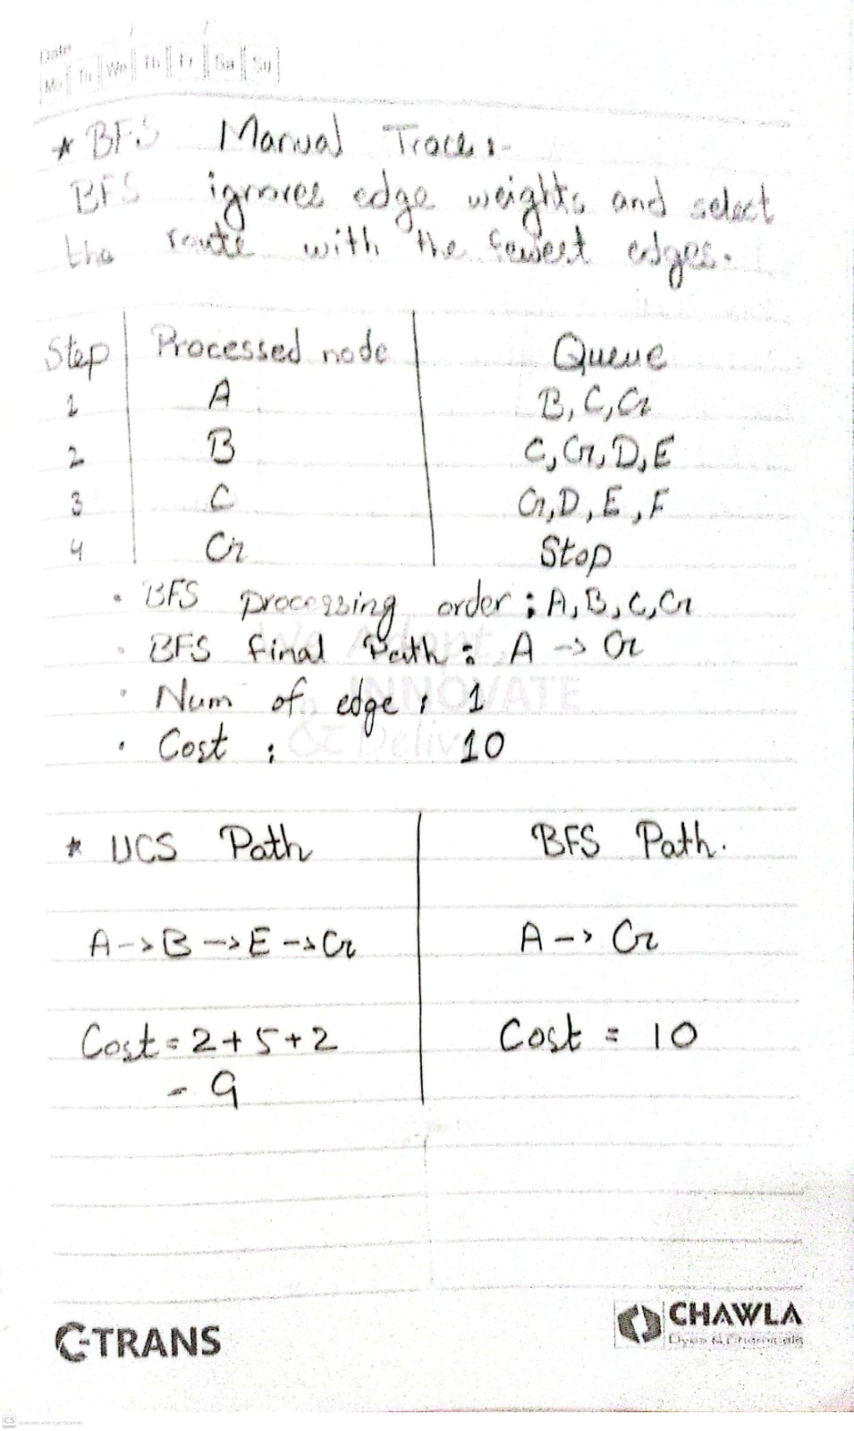
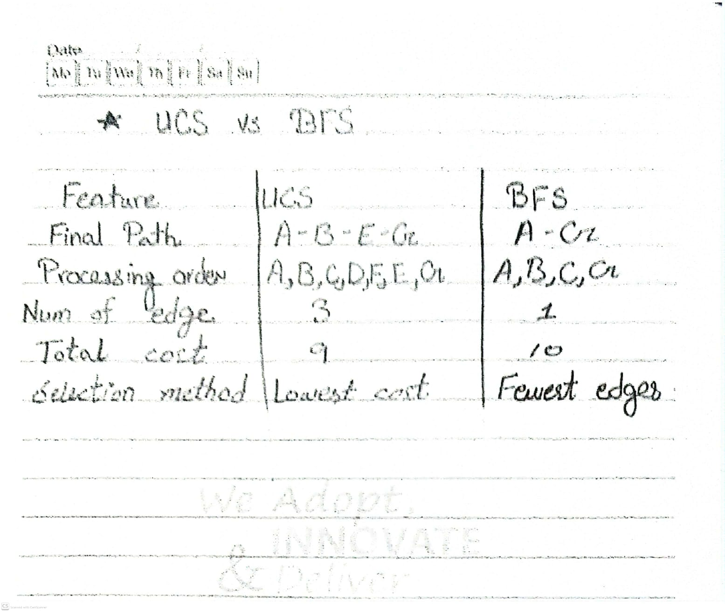

Conclusion
UCS successfully finds the minimum-cost path A → B → E → G with a total cost of 9. BFS finds the shorter route A → G with a cost of 10. This experiment demonstrates that UCS considers cumulative edge costs, while BFS considers the number of edges.

